# User′s manual

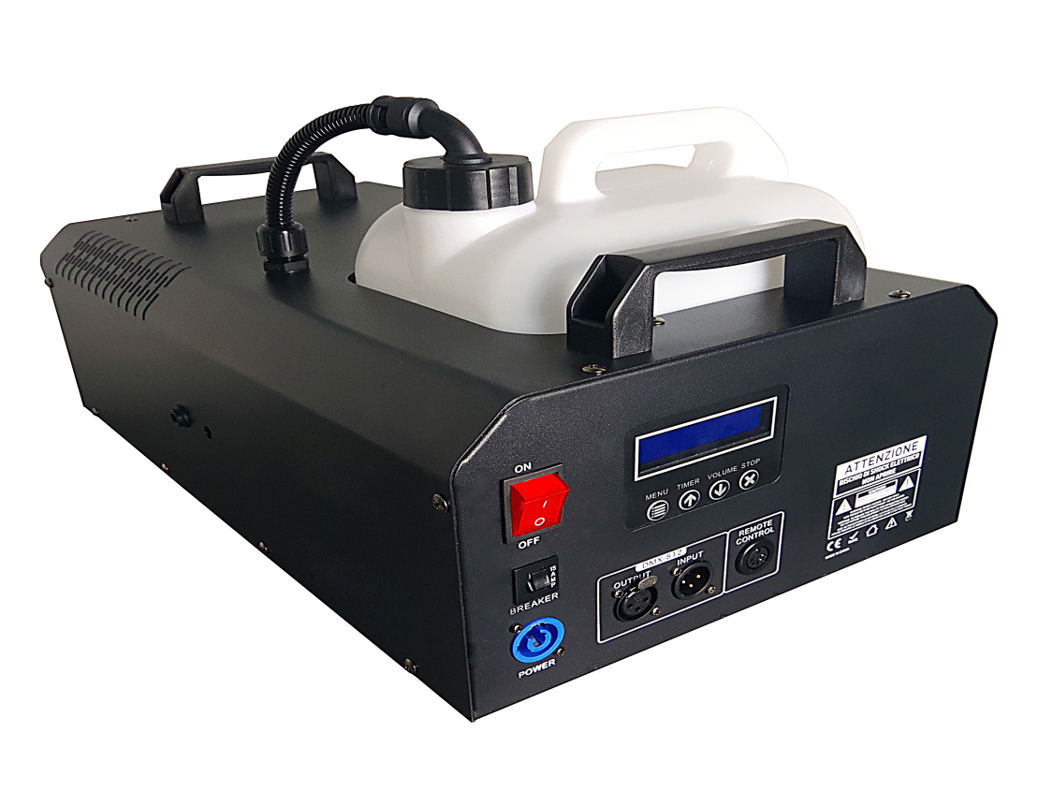

**3000W SMOKE MACHINE**

Thanks for your support to First audio products

To enjoy more comprehensive services, please register your product on the following website: http://www.fidek.com.hk/about-us

**<<Content**

Safety guidance…………………………………………………………………………………………2

Number of technologies……………………………………………………………………………5

Specification………………………………………………………………………………………………9

Trouble shooting…………………………………………………………………………………………9

cleaning………………………………………………………………………………………………………10

Important safety instructions! Please read before connection!

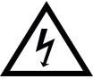DANGER! (Electrical shock due to high voltages in the device)

The housing must not be removed! There are no parts to be maintained in the device. Inside the unit there are components which are under high electrical voltage.

Before each use, check the device for damage or the absence of components, protective devices or housing parts. If this is the case, the device must not be used!

Leave maintenance and repair work to a qualified service workshop or contact your dealer. In the case of a malfunction of the device, operation must also be stopped immediately until the device has been repaired by a specialist!

DANGER! (Electric shock due to short circuit)

Modifications to the power cord or plug are prohibited. If the power cord is damaged, it must be replaced immediately with an original spare part from the manufacturer. Failure to do so may result in fire or death due to electric shock!

DANGER! (For babies and children)

Dispose of or store any packaging material properly! Packaging material must be kept out of the reach of babies and children due to the risk of suffocation.

Ensure that children never use the appliance unattended! In addition, make sure that children do not remove (small) parts from the device, as they could suffocate by swallowing parts!

Hint! (Fire hazard due to overheating)

The maximum permissible ambient temperature of this device is 40°C.

Ensure that the unit is placed in a well-ventilated location away from direct heat sources, naked flames, combustible materials, and liquids. A minimum distance of 1 m is required.

Do not tape or cover the ventilation slots of the unit.

Hint! (Operating conditions)

Due to its structural characteristics, the device is designed for indoor operation (IP20). Never expose the device to rain, moisture or liquids as this may cause damage.

Vibrations, dust or sunlight can also cause damage, avoid them!

Hint! (Power supply)

It is essential that you check that the device voltage matches your local mains voltage. It

is highly recommended that you fuse your mains socket with a residual current circuit breaker (FI).

If you do not use your device for a longer period of time or carry out maintenance work, disconnect the device from the mains in order to minimize danger. The same applies to storm conditions such as thunderstorms, floods, etc.

Hint! (Error during data transmission)

Never connect the DMX input or output to audio devices such as power amplifiers or mixing consoles!

DMX cables enable trouble-free operation and the highest possible transmission reliability of signal data. Do not use microphone cables!

Hint! (Condensation)

To avoid condensation in the unit, the unit should adapt to the ambient temperature before commissioning.

Hint! (Unwanted odors)

A new product can sometimes lead to unwanted odors. This reaction is normal and disappears after a few minutes.

Installation:

Be sure to check the unit for damage before use. Use the original packaging or a suitable transport or storage packaging to protect the product from dust, moisture, etc. when not in use.

The device can be installed either upright or suspended. The device must always be fixed to a fixed and non-combustible, approved carrier (e.g. traverse) or an appropriate surface. Note the load limit of the selected installation position (e.g. for tripods). A minimum distance of 50 cm from the walls must be maintained.

The opening of the bracket must be used to fasten the device. Always provide a second, independent safety backup for the device, e.g. with a safety cable.

Work on the device (e.g. assembly) should always be carried out from a stable and permissible platform. Make sure that the area below you is closed off.

WARNING! (Risk of injury due to falling down)

Improper installation can cause considerable injury and damage!

The installation of the device should always be carried out by experienced personnel and must be carried out in compliance with the mechanical and electrical safety regulations in your country.

Hint! (Fog fluid)

Disconnect the device from the mains before filling! Do not fill with hot liquids!

Only use high-quality water-based fog fluids recommended by your dealer. Other fog fluids can lead to clogging or dripping of the device.

**Suitable fog fluid:**

The fog fluids recommended by the manufacturer are environmentally harmless and can be disposed of via the sewer.

Make sure that there is always a sufficient amount of fog fluid in the tank.

A too low tank level can lead to pump damage and overheating of the heating element during operation!

Scope of delivery

|  |  |
| --- | --- |
| Content | Quantity |
| Fog machine | 1 |
| Tank | 1 |
| Tank cap | 1 |
| Remote control | 1 |
| Power Cord | 1 |
| Manual | 1 |

**Intended use:**

The product is used exclusively for the generation of artificial fog by vaporizing the filled fog fluid. The device may only be used for this purpose and in accordance with the operating instructions. Other purposes as well as operation under other operating conditions are expressly not intended and can lead to damage to property or personal injury! No liability is assumed for damage resulting from improper use.

It must be ensured that the device is operated exclusively by trained and competent users who are in full possession of their mental, physical and sensory abilities. The use of other persons is expressly only permitted at the request of a person responsible for their safety, who instructs or supervises the use.

**Set up:**

Connect the product to the power supply and then turn it on. Wait until the heating element has reached the operating temperature. 5. It requires about 7 minutes for heating up. When the process of heating up finishes, the LCD display will show "READY TO FOG".

The control is now carried out either by DMX, remote control or by operation on the device itself.

**Display and menu buttons:**

The device has 4 operating keys and an LCD display on which all settings can be addressed and read.

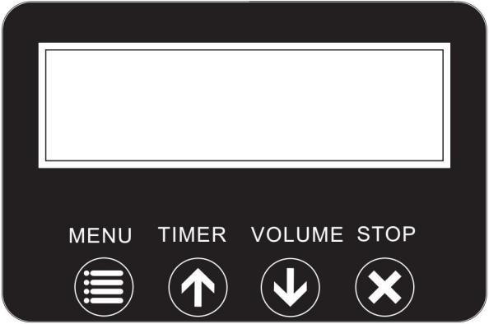

|  |  |  |
| --- | --- | --- |
| Button | Function | Description |
| Menu | Interval Set (5-200sec) | Timer-mode-setting |
| Duration Set (5-200sec) |
| Timer Out (1-100%) |
| Volume Out (1-100%) |  |
| Wireless On/Off |
| DMX Add (001-512) |
| Fluid sensor on/off |
| Timer/ Up | Up/Activate Timer function |
| Volume/ Down | Down/Activate Volume function |
| Stop | Stop/Exit |

Set interval

To set the interval, press "Menu" until "Interval set" appears on the display. Then use the Up/Down buttons to set the fog pause from 5 to 200 seconds.

This setting is required if you want to use the timer mode.

Setting the fog duration

To set the duration, press "Menu" until the display shows "Duration set". Use the Up/Down buttons to set the fog duration from 1 to 200 seconds.

This setting is required if you want to use the timer mode.

Setting the Fog Level for Timer Mode

To set the fog quantity for the timer mode, press "Menu" until the display shows "Timer out". Use the Up/Down buttons to set the fog quantity from 1 to 100%.

This setting is required if you want to use the timer mode.

Setting the Fog Level for Volume Mode

To adjust the fog quantity, press "Menu" until the display shows "Volume out". Use the Up/Down buttons to adjust the fog volume from 1 to 100%.

This setting is required if you want to use the option Volume (Continuous Mode).

Setting the DMX address

To set the DMX address, press "Menu" until the display shows "DMX ADD xxx". Then use the Up/Down buttons to set the value from 001 to 512.

Activating/deactivating the liquid sensor

Press "Menu" until "Fluid sensor" appears in the display.

Use the Up/Down buttons to activate or deactivate the fluid sensor (On/off).

When the Fluid sensor is activated, the display shows "Ready to Fazer S". If the Fluid sensor is deactivated, the display shows "Ready to Faze".

Timer Mode

In the timer mode, the fog machine will automatically emit fog. The time intervals, duration and fog volume depend on the corresponding menu settings. Press the TIMER button, to activate the timer mode. The display indicates the set time interval:

Interval xxx s

The unit counts down to 0 seconds and emits fog. To deactivate the timer mode, press the Stop

button.

Press the VOLUME button, to activate continuous fog output. The display indicates Volume followed by the value that was set in menu item “Volume Out”:

Remote control mode:

The device can be managed remotely using the remote control included in the scope of delivery. To do this, plug the wireless receiver into the connection on the rear of the unit. Please note that the device cannot be controlled by remote control if it is connected to DMX.

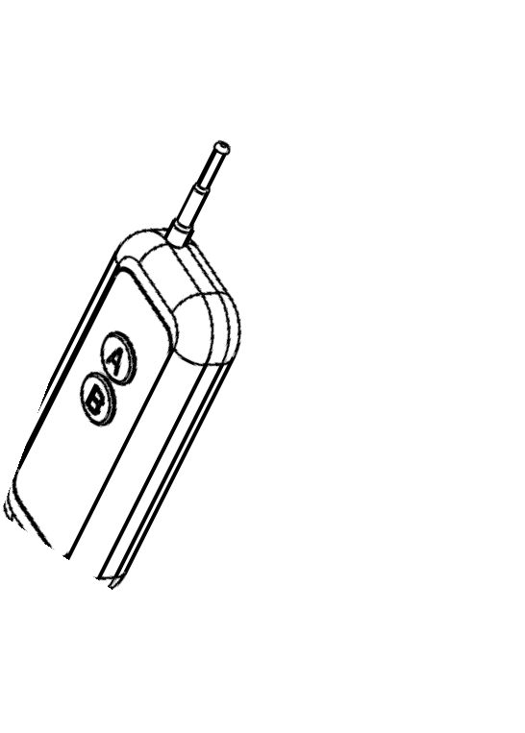

The remote control has 2 or 4 buttons: Press and hold any of the buttons(A/B/C/D) to trigger a permanent fog emission. To stop the fog output, release the button.

DMX mode:

Configuration of the DMX connector

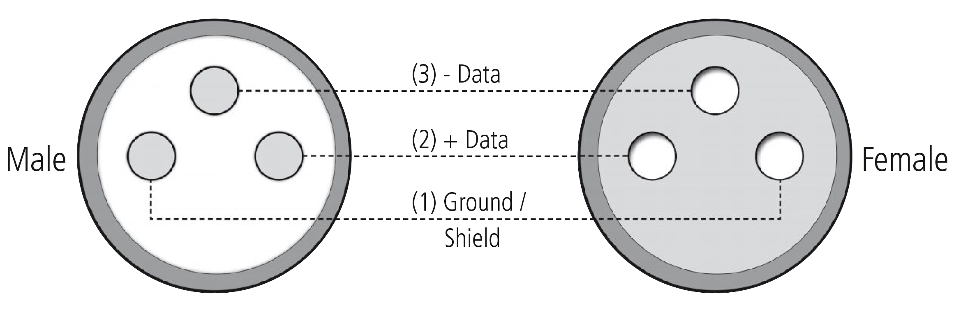

Resistance 120 ohm // ¼ w between pin 2 (DMX-) and pin 3 (DMX+) of the last fixture.

Connect the DMX input of your device to the DMX output of your DMX controller, your DMX software or the DMX output of a device already in your DMX chain. Always use a DMX cable with a 110 Ohm resistor for this connection. Address the device according to your DMX configuration. The following table shows the respective DMX modes of the individual devices with the corresponding values and functions:

|  |  |  |
| --- | --- | --- |
| Channel | Scale | Function |
| 1 | 000-005 | Off |
|  | 006-255 | 1-100% Fog Output |

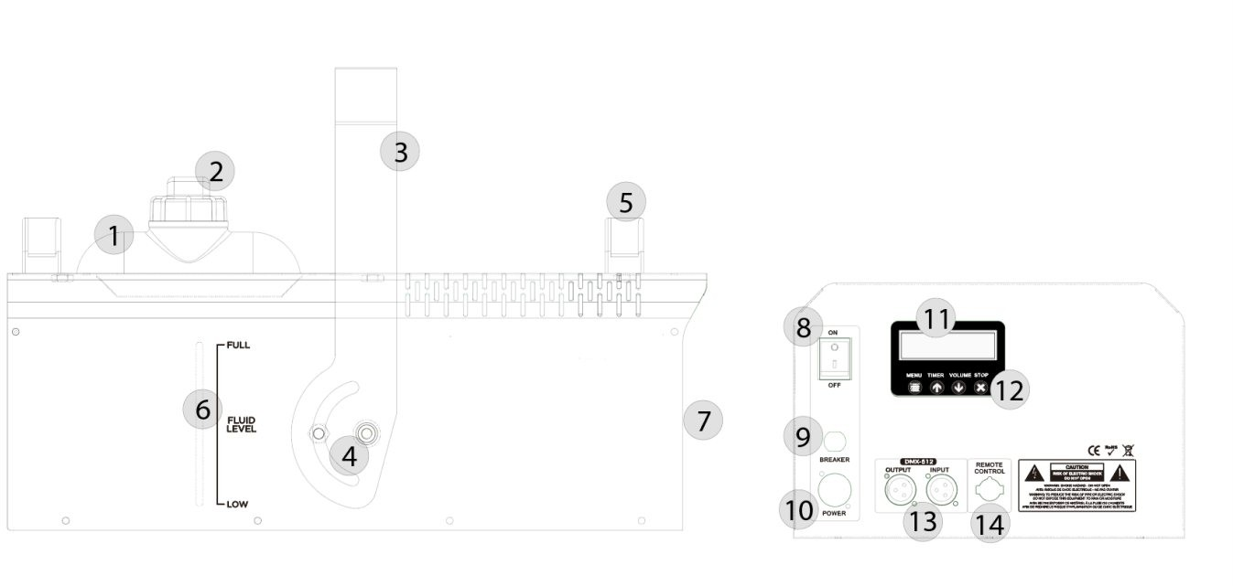

|  |  |  |  |
| --- | --- | --- | --- |
| No. | Designation | No. | Designation |
| 1 | Fluid Tank | 8 | On/Off-Switch |
| 2 | Tank cap | 9 | Fuse |
| 3 | Mounting bracket | 10 | Power cord (Power Con compatible) |
| 4 | Locking screw | 11 | Menu buttons |
| 5 | Carrying handle | 12 | Display |
| 6 | Tank indicator | 13 | DMX-In/Out (3-pol) |
| 7 | Nozzle for fog output | 14 | Receiver remote control |

**<<Specification**

|  |  |
| --- | --- |
| Model | |
| Power supply | AC220-240V, 50HZ |
| Power consumption | 3000 Watt |
| Power connections | Power Con compatible |
| Fuse | 250V/15A |
| Heating time | 5 minutes |
| Fluid consumption | 300ml/min |
| Tank capacity | 6 Liters |
| Output range | 10m |
| DMX-Connector | DMX-In/Out (3pol) |
| DMX-channels | 1 channel-mode |
| Dimensions (with bracket) L x W x H | 510 x 331 x 335 mm |
| Weight | 15,4 Kg |

**<<Trouble shooting:**

The following overview serves as an aid for quick troubleshooting. If you are unsure, contact the manufacturer, the dealer or the corresponding specialist personnel. Never open the device on your own!

|  |  |
| --- | --- |
| No function | Check the mains connection and the fuse |
| No fog output | Check the fill level of the fluid container |
| No reaction in DMX mode | Check the cable connections |
| Check your DMX address setting |
| If available, try an alternative DMX controller |
| No reaction in remote mode | Change the battery in your remote control |
| Ensure that the IR transmitter and receiver are at close and clear distances from each other |

Cleaning:

The heating element should be cleaned regularly (every 30 operating hours) to avoid deposits. In addition, regular cleaning of lines and nozzles is strongly recommended.

Please use only high quality cleaning fluids!

Procedure:

* Empty the fog machine and pour the cleaner into the tank as delivered.
* Operate the fog function of the machine a few times in a well ventilated place.
* Adapt the number of required repetitions to the degree of soiling.
* Remove the cleaner completely and rinse the tank properly with distilled water.
* Environmental protection:
* The company always strives to reduce the burden of packaging to a minimum. The use of environmentally friendly and recyclable materials is of fundamental importance to us. Please dispose of and recycle the packaging components after use properly.

Disposal of packaging:

* Ensure that paper packaging, plastic materials, etc. are separately recycled. Observe the corresponding disposal instructions on the packaging.

Disposal of batteries:

* Batteries do not belong in the garbage! Please keep batteries in accordance with the official collection points or disposal stations in accordance with the specifications.

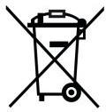Disposal of your old device:

* Do not dispose of the device with household waste! This device is subject to the WEEE Directive (Waste Electrical and Electronic Equipment) in its currently valid version.
* The device will be disposed of by an approved waste disposal company or your local waste disposal office. The regulations valid in your country must be observed!
* 

**First Audio Manufacturing( Guangzhou) Ltd**

If you have any questions or suggestions about First Audio products, please contact Feida customer service center

Free service hotline: 8008303013

400 customer service hotline: 4008308282

Website: http://www.fidek.com.hk/about-us

Manufacturer: Guangzhou Feida audio Co., Ltd. address: Tanbu Feida Industrial Park, Huadu District, Guangzhou City, Guangdong Province

